Lab 3.1 — The AI Command Center: Rapid Prototyping with Python

Table of Contents
Table of Contents 2
Introduction 3
Learning Objectives 3
Prerequisites 3
Part 1 — Seeding the Operational Data 4
Step 1 — Create the Analytics Table 4
Step 2 — Ingest the Mock Operational Data 5
Step 3 — Verify the Data Seeding 7
Part 2 — Building the Enterprise Python Dashboard 8
Step 1 — Create a New Streamlit App 8
Step 2 — Injecting Cortex, Filtering, and Caching 8
Step 3 — Interacting with the Dashboard 12
Knowledge Check 13
Clean Up 14
Troubleshooting 14
Symptom: invalid identifier 'SNOWFLAKE.CORTEX.COMPLETE' 14
Symptom: Dashboard throws a KeyError on AI_TRIAGE_CATEGORY. 14
Conclusion 15

Introduction
Modern dashboards are no longer just for visualizing historical data; they are evolving into active "Command Centers." However, many traditional BI platforms struggle to natively integrate LLMs, handle dynamic text summarization, or optimize the compute costs of Generative AI.
By using Python and Streamlit in Snowflake (SiS), we can build a completely custom, AI-native BI dashboard in minutes. In this lab, you will build an interactive Python Command Center. You will write code that calls Snowflake Cortex functions (SUMMARIZE, COMPLETE, and SENTIMENT) directly within a data pipeline.
Crucially, you will implement Enterprise Caching Best Practices to ensure your dashboard is highly performant and cost-effective, bypassing the need to re-run expensive LLM queries every time a user interacts with the UI.

Learning Objectives
Upon completing this lab, you will be able to:
- Seed operational data in Snowflake for dashboard consumption.
- Create an interactive Python-based BI dashboard using Streamlit in Snowflake (SiS).
- Utilize Streamlit's @st.cache_data decorator to optimize LLM inference latency and compute costs.
- Call SNOWFLAKE.CORTEX.SENTIMENT to generate numerical KPIs from unstructured text.
- Apply SNOWFLAKE.CORTEX.COMPLETE and SUMMARIZE via Snowpark to generate dynamic, prescriptive insights.
- Render AI-generated categorical data into interactive metrics and charts using Python.

Prerequisites
Before starting, ensure you have:
- Access to the Snowsight Web UI.
- The SYSADMIN role (or equivalent) in Snowflake to create tables.
- The SNOWFLAKE.CORTEX_USER role granted to your active session.

Part 1 — Seeding the Operational Data
Before we can visualize data in our dashboard, we must create a robust mock dataset representing the operational data a Customer Success Manager might analyze. To ensure our BI dashboard provides meaningful insights, we will construct a table with varied regions, tiers, and complex support transcripts.

Step 1 — Create the Analytics Table
Execute the following SQL commands in a standard Snowflake Snowsight Worksheet to initialize the database context and define the schema for our support queue.
USE DATABASE ENTERPRISE_AI_SANDBOX;
USE SCHEMA ANALYTICS;

CREATE OR REPLACE TABLE customer_support_tickets (
ticket_id VARCHAR(20),
customer_tier VARCHAR(50),
region VARCHAR(50),
issue_transcript VARCHAR(1000),
created_at TIMESTAMP_NTZ DEFAULT CURRENT_TIMESTAMP()
);
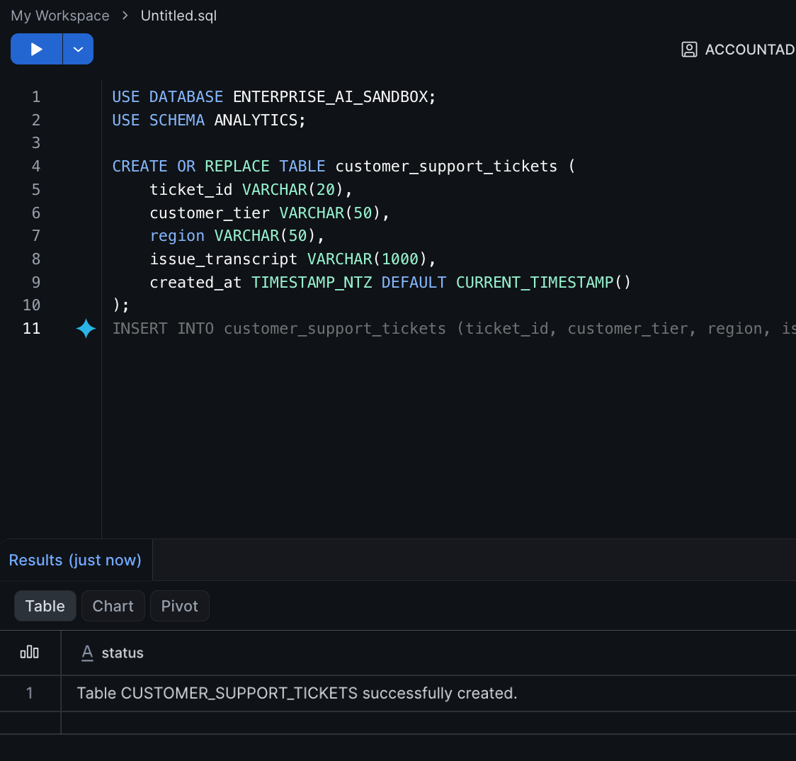
Expected Output:
Table CUSTOMER_SUPPORT_TICKETS successfully created.

Step 2 — Ingest the Mock Operational Data
Now that the schema is established, we will insert a comprehensive set of mock tickets. This varied dataset ensures our Cortex models have enough context to generate interesting sentiment scores, distinct categories, and regional summaries.
INSERT INTO customer_support_tickets (ticket_id, customer_tier, region, issue_transcript) VALUES
('TKT-901', 'Enterprise', 'NA', 'System is completely down. We cannot process any transactions. We are losing money every minute. Fix this immediately!'),
('TKT-902', 'Enterprise', 'NA', 'We are experiencing severe latency on the checkout page. It takes 30 seconds to load.'),
('TKT-903', 'SMB', 'EMEA', 'How do I reset my password? The email link expired.'),
('TKT-904', 'Enterprise', 'EMEA', 'The new API endpoints are throwing 500 errors when we pass pagination parameters.'),
('TKT-905', 'SMB', 'NA', 'Can I upgrade my billing plan to include more API calls?'),
('TKT-906', 'Enterprise', 'APAC', 'The reporting dashboard is missing data from yesterday. Our execs need this for the board meeting.'),
('TKT-907', 'Mid-Market', 'NA', 'Integration with Salesforce is failing with an authentication error. Need assistance re-configuring the OAuth token.'),
('TKT-908', 'SMB', 'APAC', 'The UI is very slow today when loading the customer list. It used to be instant.'),
('TKT-909', 'Enterprise', 'EMEA', 'Critical vulnerability reported by our security team on the older API v1 endpoint. Need immediate patch or migration strategy.'),
('TKT-910', 'Mid-Market', 'EMEA', 'Billing discrepancy. We were charged for 50 licenses but only have 45 active users.'),
('TKT-911', 'Enterprise', 'NA', 'Can you provide the SOC2 compliance report for our vendor assessment?'),
('TKT-912', 'SMB', 'NA', 'I accidentally deleted a project workspace. Is there any way to recover it?');

Expected Output:
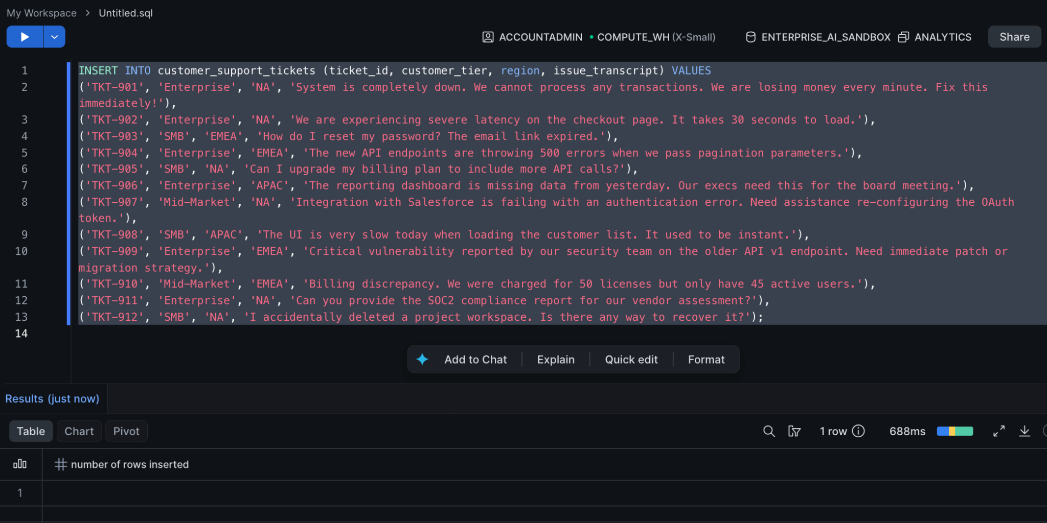

Step 3 — Verify the Data Seeding
Run a quick SELECT query to confirm the data was inserted properly before moving to the Python dashboard.
SELECT * FROM customer_support_tickets ORDER BY ticket_id;
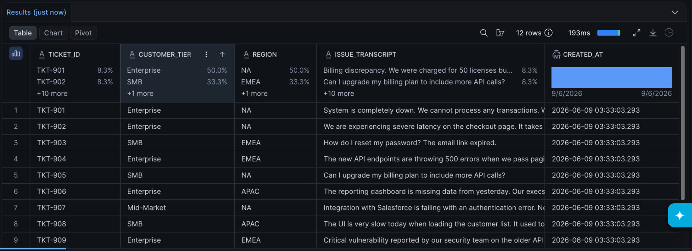

Part 2 — Building the Enterprise Python Dashboard
We will now transition to Streamlit to create our visual dashboard.

Step 1 — Create a New Streamlit App
- In the left navigation menu of Snowsight, click on Workspaces and select your active workspace.
- Click the + Add new button and select Streamlit App.
- Name the application AI Command Center and confirm.
- Delete all the boilerplate code in the left editor.

Step 2 — Injecting Cortex, Filtering, and Caching
In a production environment, if 50 users load a dashboard, you do not want to execute the Cortex COMPLETE function 50 times on the same exact data. Streamlit uses a reactive execution model, meaning UI interactions trigger full script reruns.
To solve this, we will use the @st.cache_data decorator. This executes the AI SQL query once and caches the resulting Pandas DataFrame in memory for a specified time-to-live (TTL).
Paste the following comprehensive script into your editor.
import streamlit as st
from snowflake.snowpark.context import get_active_session

# 1. Set up the Dashboard UI
st.set_page_config(layout="wide", page_title="AI Command Center")
st.title("📊 AI Support Command Center")
st.markdown("Real-time ticket triage, sentiment analysis, and summarization using Snowflake Cortex.")

# 2. Connect to Snowflake
session = get_active_session()
session.use_database("ENTERPRISE_AI_SANDBOX")
session.use_schema("ANALYTICS")

# 3. Sidebar UI Controls
st.sidebar.header("Dashboard Controls")
selected_region = st.sidebar.selectbox("Filter by Region:", ["All", "NA", "EMEA", "APAC"])

# Build dynamic SQL WHERE clause based on UI state
where_clause = "" if selected_region == "All" else f"WHERE region = '{selected_region}'"

# 4. Enterprise Best Practice: Cache AI Data
# This prevents expensive LLM re-runs when the user just clicks a filter
@st.cache_data(show_spinner=False, ttl=600)
def fetch_ai_enriched_tickets(query_filter):
query = f"""
SELECT
ticket_id,
customer_tier,
region,
SNOWFLAKE.CORTEX.SENTIMENT(issue_transcript) AS SENTIMENT_SCORE,
SNOWFLAKE.CORTEX.COMPLETE(
'llama3.1-8b',
'Categorize this ticket into one of three buckets: [URGENT OUTAGE, TECHNICAL BUG, ACCOUNT ADMIN]. Return ONLY the bucket name. Transcript: ' || issue_transcript
) AS AI_TRIAGE_CATEGORY,
SNOWFLAKE.CORTEX.COMPLETE(
'llama3.1-8b',
'Analyze this support ticket. Return ONLY a 3-to-5 word "Next Best Action". Ticket: ' || issue_transcript
) AS NEXT_BEST_ACTION,
issue_transcript
FROM
customer_support_tickets
{query_filter};
"""
return session.sql(query).to_pandas()

st.divider()

# 5. Execute Data Fetch
with st.spinner("Cortex AI is analyzing current support tickets..."):
df_tickets = fetch_ai_enriched_tickets(where_clause)

# 6. Render Dynamic Top-Level KPI Metrics
st.subheader("Global Health Metrics")
total_tickets = len(df_tickets)
avg_sentiment = df_tickets['SENTIMENT_SCORE'].mean() if total_tickets > 0 else 0

# Calculate how many tickets the AI categorized as URGENT
urgent_count = len(df_tickets[df_tickets['AI_TRIAGE_CATEGORY'] == 'URGENT OUTAGE'])

col_m1, col_m2, col_m3 = st.columns(3)
col_m1.metric("Total Queued Tickets", total_tickets)
col_m2.metric(
"Average AI Sentiment",
f"{avg_sentiment:.2f}",
delta="Negative Trend" if avg_sentiment < 0 else "Positive Trend",
delta_color="inverse"
)
col_m3.metric("Critical AI Outages Detected", urgent_count)

st.divider()

# 7. Render AI Queue and Visualizations
st.subheader("Live Ticket Triage Queue")
st.dataframe(df_tickets, use_container_width=True)

st.divider()
col1, col2 = st.columns(2)

with col1:
st.subheader("Ticket Volume by AI Category")
# Group data by the AI's categorical output
if total_tickets > 0:
category_counts = df_tickets['AI_TRIAGE_CATEGORY'].value_counts()
st.bar_chart(category_counts, color="#FF4B4B")

with col2:
st.subheader(f"Executive Summary ({selected_region})")
if total_tickets > 0:
# Macro summary of the filtered view
summary_query = f"""
SELECT SNOWFLAKE.CORTEX.SUMMARIZE(
LISTAGG(issue_transcript, ' | ')
) AS REGIONAL_SUMMARY
FROM customer_support_tickets
{where_clause};
"""
summary_result = session.sql(summary_query).collect()
st.info(summary_result[0]['REGIONAL_SUMMARY'])
else:
st.warning("No tickets found to summarize.")
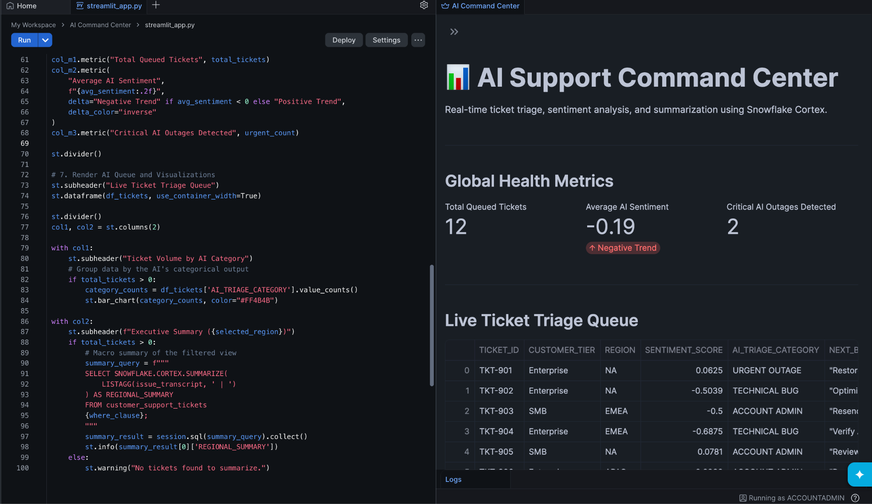
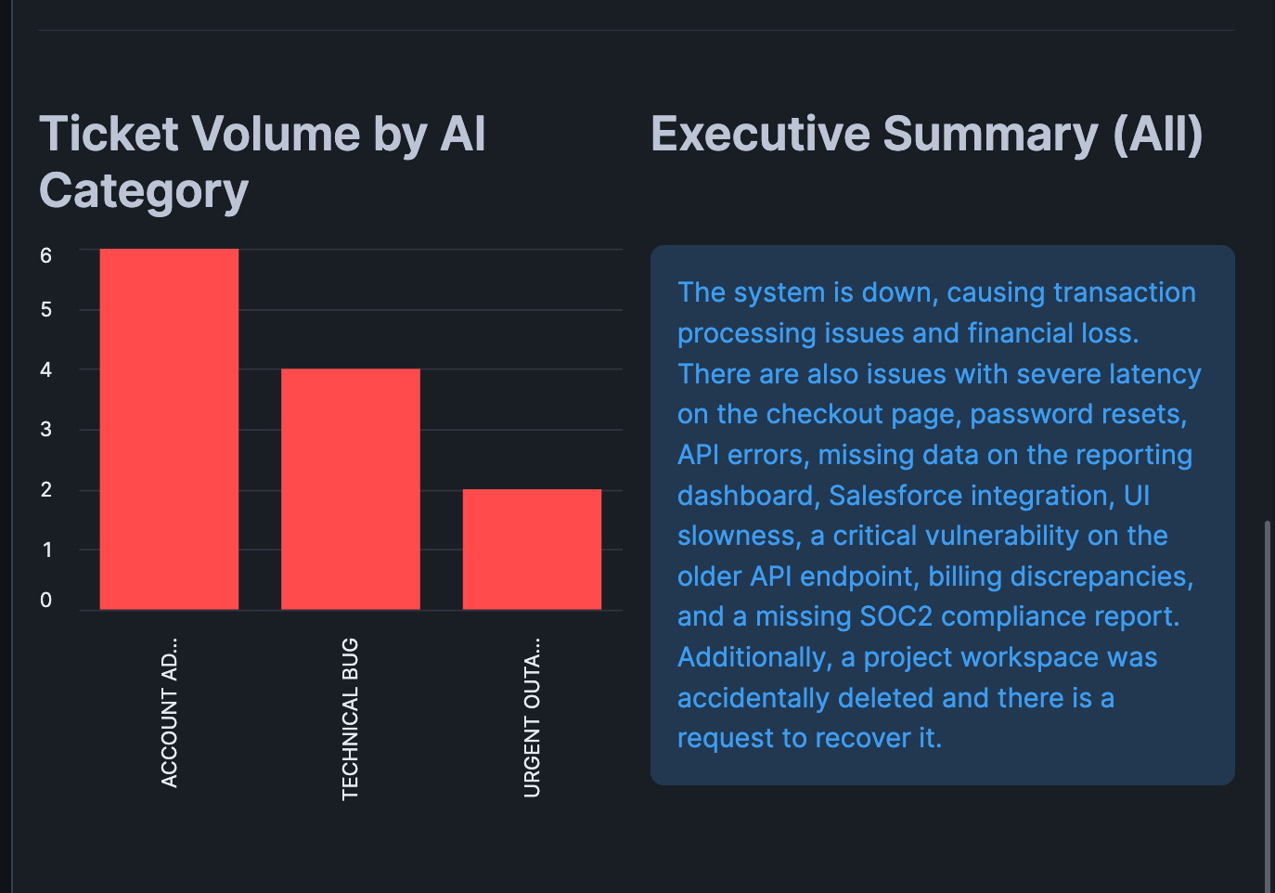

Click Run (or Cmd/Ctrl + Enter) in the top left.

Step 3 — Interacting with the Dashboard
- Observe the Global Health Metrics at the top. The SENTIMENT_SCORE ranges from -1 (very negative) to 1 (very positive). Notice how the AI detected negative sentiment automatically from the text.
- In the left-hand Dashboard Controls sidebar, change the Region filter from "All" to "NA".
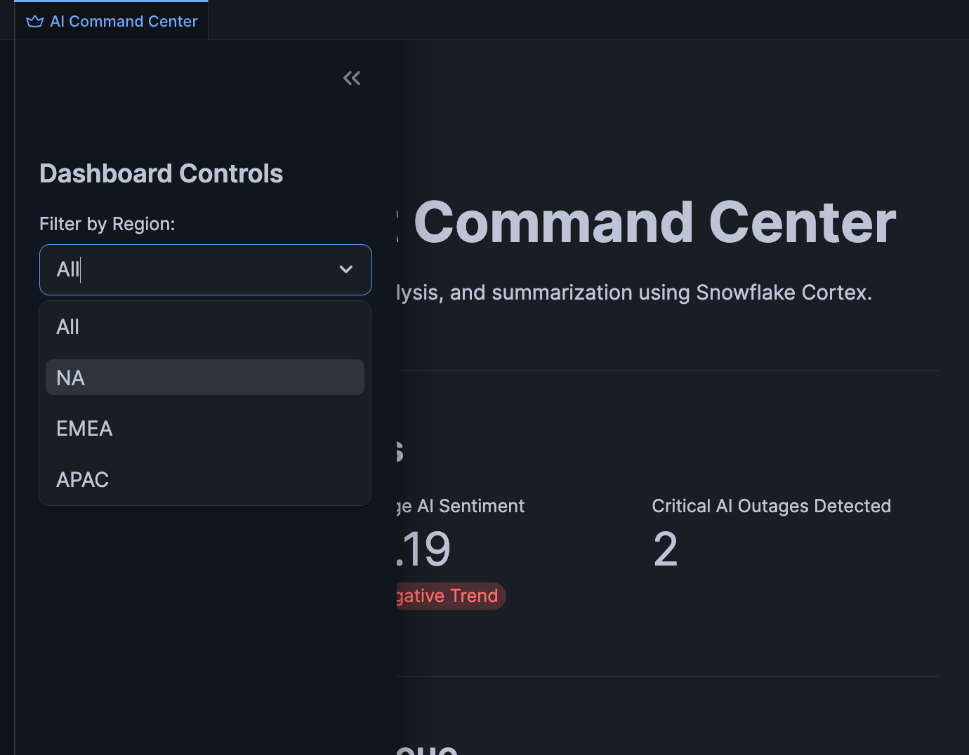
- The dashboard will update the metrics, the Bar Chart, and generate a new summary instantly. Because of the @st.cache_data decorator, Streamlit knows it has already executed the Cortex query for "NA" during the initial "All" load, saving you compute credits and eliminating latency.

Knowledge Check
- Why is the @st.cache_data decorator critical when embedding Large Language Models into a BI Dashboard?
  - Answer: UI interactions (like clicking a dropdown filter) cause Python/Streamlit scripts to rerun from top to bottom. Without caching, the dashboard would re-issue the expensive LLM prompt to the database every single time a user clicks the screen. Caching stores the result in memory, drastically reducing cloud compute costs and rendering the dashboard instantly for the user.
- How does SNOWFLAKE.CORTEX.SENTIMENT differ from SNOWFLAKE.CORTEX.COMPLETE in this pipeline?
  - Answer: COMPLETE generates unstructured text (words and phrases) based on a prompt. SENTIMENT is a specialized, optimized model that returns a structured float (a number between -1 and 1). This mathematical output is crucial for dashboards, as it allows Data Engineers to calculate averages and render quantitative KPI metrics (like the Average Sentiment gauge) from unstructured text.

Clean Up
To keep your workspace clean, you can delete the Streamlit app if desired.
- Navigate back to your Workspace.
- Click the three dots (...) next to AI Command Center and select Delete.

Troubleshooting

Symptom: invalid identifier 'SNOWFLAKE.CORTEX.COMPLETE'
Solution: The execution context within the Streamlit app lacks the proper privileges. Ensure that your user role has the SNOWFLAKE.CORTEX_USER database role granted to it, as the get_active_session() inherits your current UI role.

Symptom: Dashboard throws a KeyError on AI_TRIAGE_CATEGORY.
Solution: LLMs are non-deterministic. Occasionally, the COMPLETE function might wrap the output in quotes or markdown (e.g., "URGENT OUTAGE" instead of URGENT OUTAGE). This can affect Pandas grouping. If this happens, append .str.replace('"', '') to the column access in Python, or adjust your prompt in the SQL query to strictly forbid punctuation.

Conclusion
In this lab, you successfully built an intelligent, enterprise-grade AI Command Center entirely in Python. By utilizing Streamlit in Snowflake, you pushed Cortex AI inference directly down to the data layer and captured the results in Pandas DataFrames. More importantly, you learned how to optimize AI compute costs using programmatic caching (@st.cache_data) and transformed raw text into quantitative metrics using Sentiment Analysis—overcoming the strict limitations of legacy BI tools.

